# CS 255 System Design Document Template

This template lays out all the different sections that you need to complete for Project Two. Each section has guidance to prompt your thinking. You will need to continually reference the interview transcript as you work to make sure that you are addressing your client’s needs. There is no required length for the final document. Instead the goal is to complete each section based on what your client’s needs are. Remove this note when you are finished, and replace all bracketed text with the relevant information.

## UML Diagrams

### UML Use Case Diagram

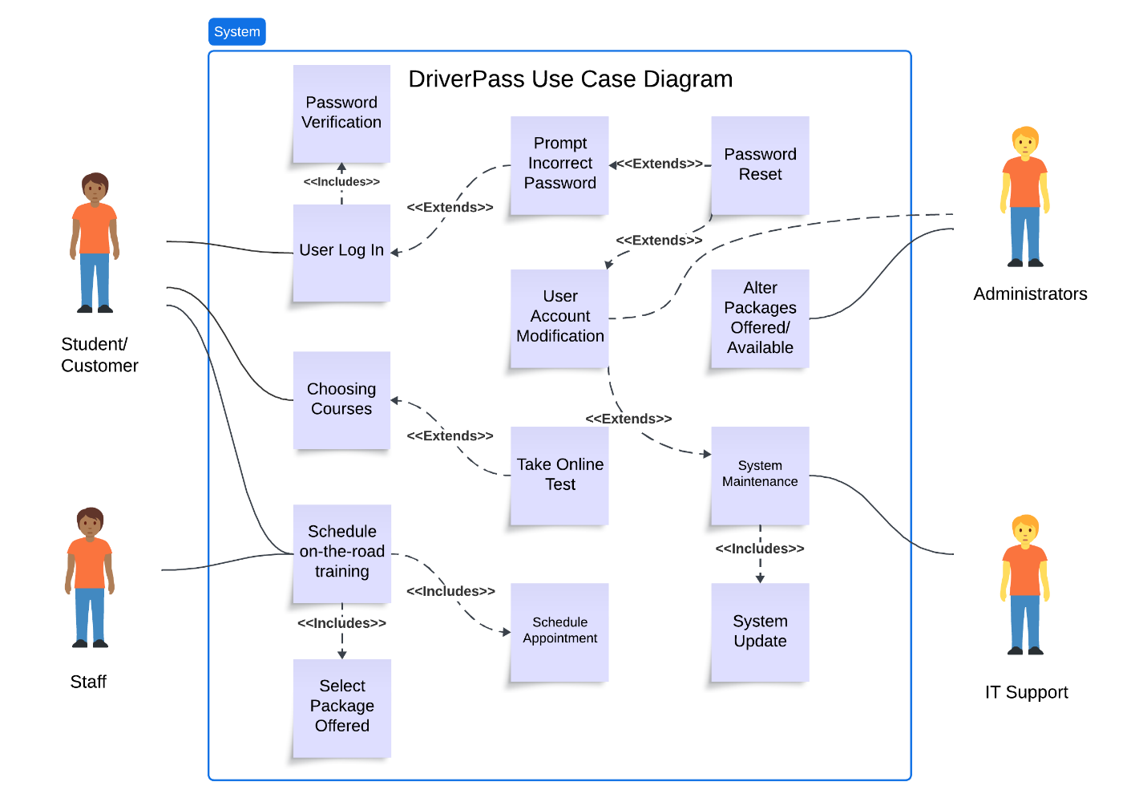

### UML Activity Diagrams

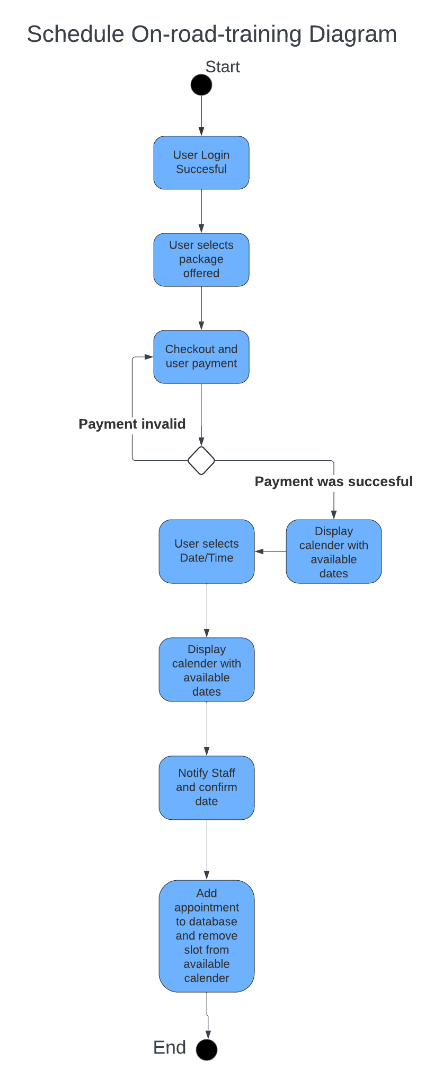

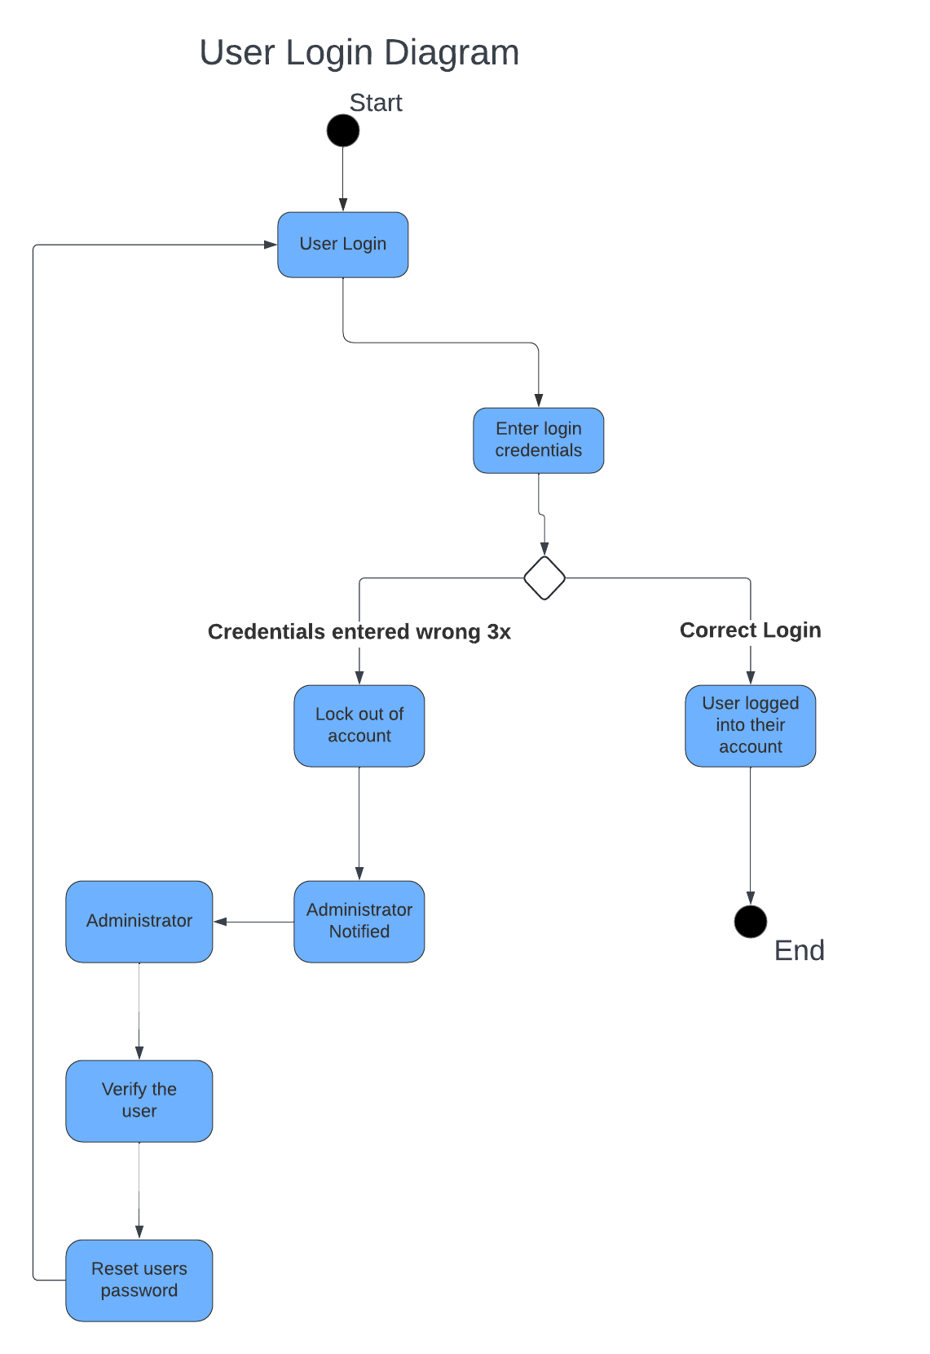

### UML Sequence Diagram

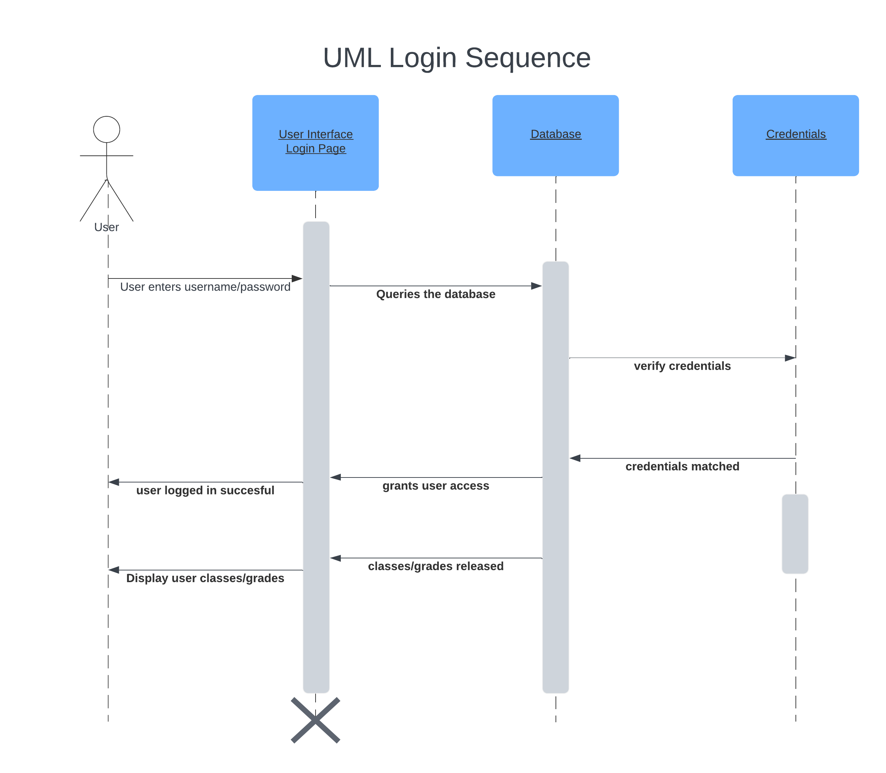

### UML Class Diagram

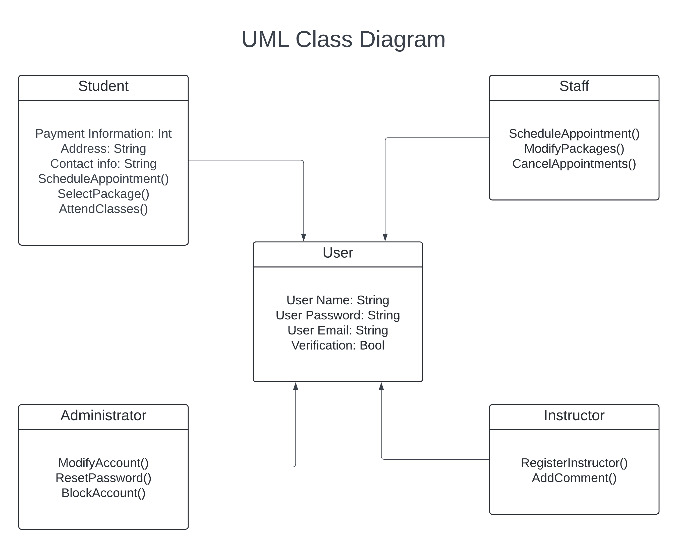

## Technical Requirements

The technical requirements of this system design include the user request and payments to both be valid. The user need to enter correct information for the login requests. The user permission differing between students, staff and admins. Alongside the permissions based on the role, there is the ability to modify and disable packages and reset passwords.